

Council of Governors (Public Meeting)

Tuesday 10 July 2018

OUR STRATEGIC OBJECTIVES
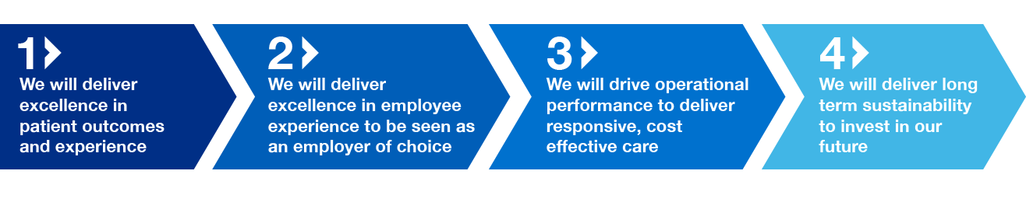
Council of Governors (Public)

Please note that in accordance with the Council of Governors Standing Orders, no filming or recording of the meeting is permitted. There will be an opportunity for questions and comments from members of the public at the end of the meeting.

Agenda

 | SUBJECT | PAPER | LEAD | TIME
1 | Welcome | verbal | Chairman | 1.30pm
2 | 70 Years of NHS -  South Tees Hospitals NHS FT - ITN | video
3 | Apologies for absence | verbal | Chairman
4 | Declarations of Interests  Any new conflict of interest and any actual or potential conflict of interest in relation to any matter to be discussed | A | Chairman
5 | Minutes of the meeting held on 8 May 2018  To receive and approve the minutes from the meeting held on 8 May 2018 | B | Chairman | 1.45pm
6 | Matters Arising | verbal | Chairman | 1.50pm
7 | Action Log | C | Chairman | 1.55pm
8 | Chairman’s Report  To receive a report from the Chairman | D | Chairman | 2.00pm
9 | Chief Executive’s Report  To receive a report from the Chief Executive including update on strategy development | E | Chief Executive | 2.10pm
10 | Presentation from External Auditors | presentation | KPMG | 2.30pm
 | GOVERNANCE
11 | Nomination Committee Meeting - Recommendation | verbal | Chairman | 3.00pm
 | GOVERNORS TOPIC OF INTEREST
12 | Presentation from David Chadwick  Planned & Specialist Care – Centre Update | verbal | Medical Director – Planned & Specialist Care | 3.15pm
13 | Any Other Business |  |  | 3.45pm
14 | Evaluation of Meeting |  |  | 3.55pm
15 | Future meeting dates - for information  Governors are asked to note key dates relating to the schedule of Formal Council of Governors meetings and training up to March 2019 | F | Chairman
16 | Time and Date of next meeting  The next meeting of the Council of Governors to be held in public is scheduled to take place on Tuesday 9 October 2018 at 3.00pm in the Board Room, James Cook University Hospital, TS4 3BW.

